**01-IntroductiontoPython-Variables-Datatypes Input/Output-Formatting**

**Ex. No. : 1.1 Date:06/03/2024**

**RegisterNo.:231801171 Name:Stergio Eugin**

## [ConvertingInputStrings](https://www.rajalakshmicolleges.net/moodle/mod/quiz/view.php?id=6373)

Writeaprogramtoconvertstringstoanintegerandfloatanddisplayitstype.

*Sample Output:* 10,<class 'int'> 10.9,<class'float'>

**Forexample:**

|  |  |
| --- | --- |
| **Input** | **Result** |
| 10  10.9 | 10,<class 'int'> 10.9,<class'float'> |

# Program:

a=input() b=input() c=int(a) d=float(b)

print(c,type(c),sep=",")

print("{:0.1f}".format(d),type(d),sep=",")

# Output:

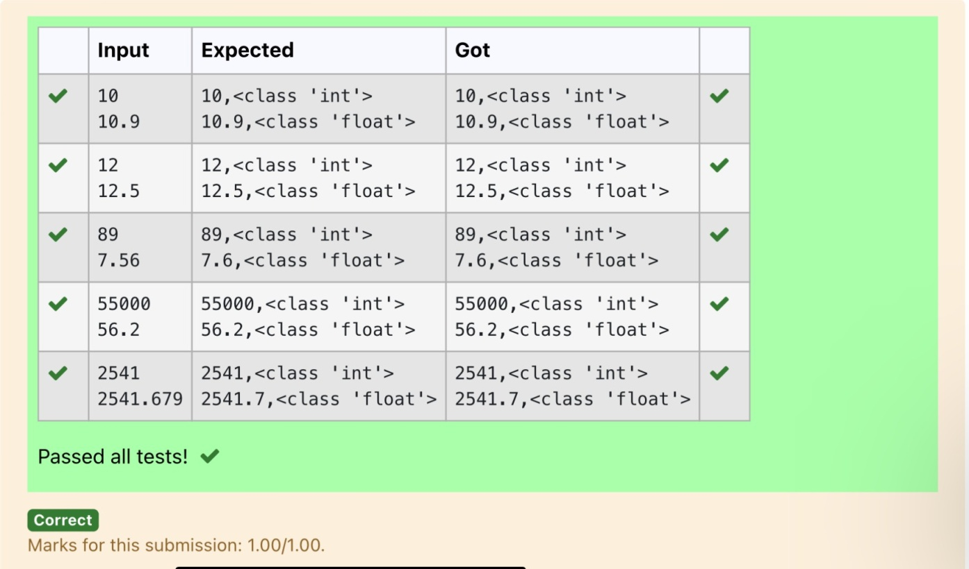

**Ex. No. : 1.2 Date: 6/3/24**

**RegisterNo.:231801171 Name: Stergio Eugin**

## [GrossSalary](https://www.rajalakshmicolleges.net/moodle/mod/quiz/view.php?id=6374)

Ramesh’s basic salary is input through the keyboard. His dearness allowance is 40% of his basic salary, and his house rent allowance is 20% of his basic salary. Write a program to calculate his gross salary.

*SampleInput:*

10000

*SampleOutput:*

16000

**Forexample:**

|  |  |
| --- | --- |
| **Input** | **Result** |
| 10000 | 16000 |

# Program:

s=int(input()) da=s*0.4 ha=s*0.2

print(int(s+da+ha))

# Output:

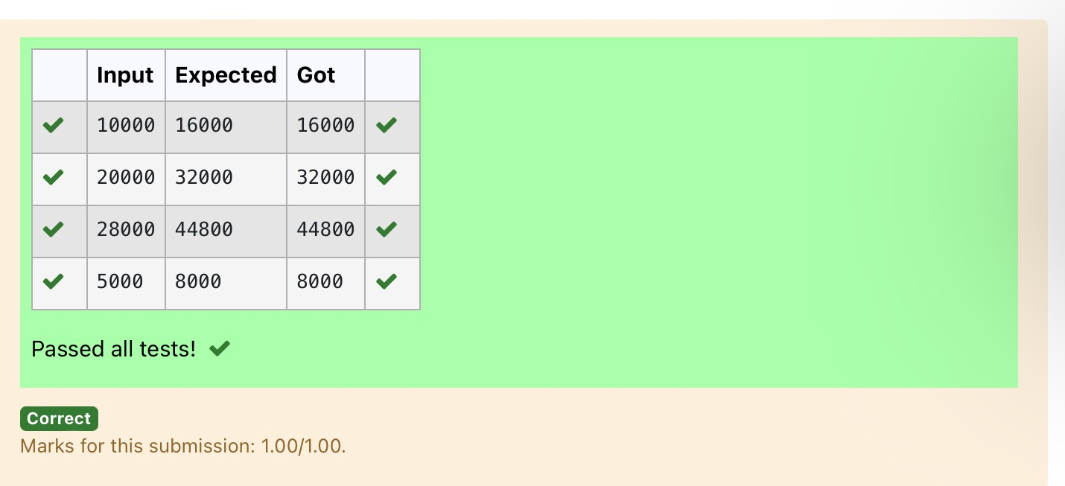

**Ex. No. : 1.3 Date: 6/3/24**

**RegisterNo.:231801171 Name:Stergio Eugin**

## SquareRoot

Write a simple python program to find the square root of a given floating pointnumber. The output should be displayed with 3 decimal places.

SampleInput: 8.00

SampleOutput: 2.828

**Forexample:**

|  |  |
| --- | --- |
| **Input** | **Result** |
| 14.00 | 3.742 |

# Program:

import math a=float(input()) s=math.sqrt(a) print("{:.3f}".format(s))

# Output:

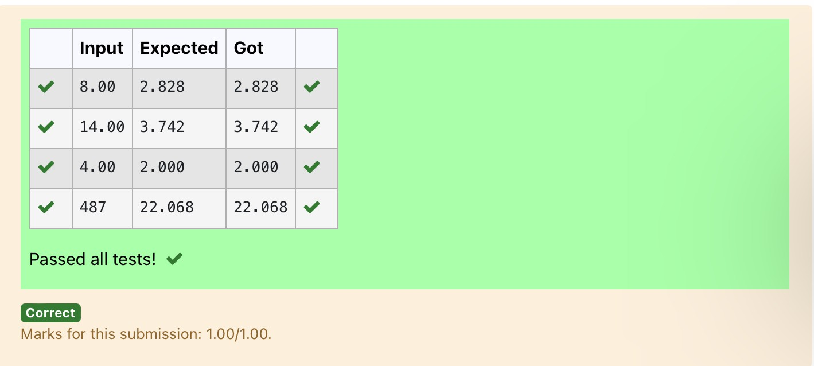

**Ex. No. : 1.4 Date:**

**Register No.: 231801171 Name: Stergio Eugin**

## [Gainpercent](https://www.rajalakshmicolleges.net/moodle/mod/quiz/view.php?id=6376)

AlfredbuysanoldscooterforRs.XandspendsRs.Yonitsrepairs.Ifhesellsthe scooterforRs.Z(Z>X+Y). WriteaprogramtohelpAlfredtofindhisgainpercent. Get all the above-mentioned values through the keyboard and find the gain percent.

InputFormat:

ThefirstlinecontainstheRsX The second line contains Rs Y The third line contains Rs Z Sample Input:

10000

250

15000

SampleOutput:

46.34isthegainpercent.

**Forexample:**

|  |  |
| --- | --- |
| **Input** | **Result** |
| 45500  500  60000 | 30.43isthegainpercent. |

# Program:

buys=int(input())

repair=int(input()) sells=int(input())

g=(((sells-(buys+repair))/(buys+repair))*100) print("{:.2f}".format(g),"isthegainpercent.")

# Output:

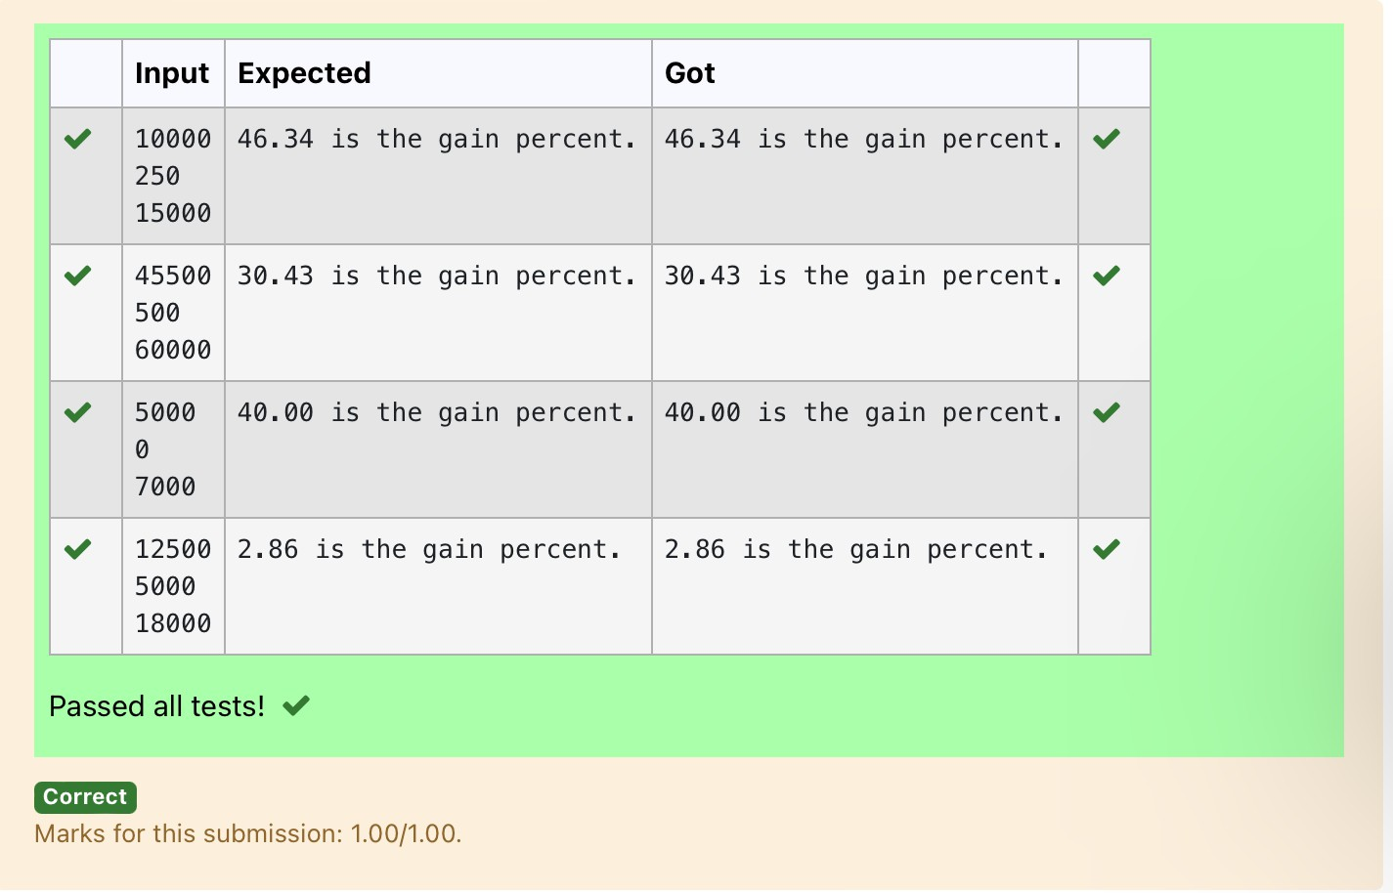

**Ex. No. : 1.5 Date: 06/03/2024**

**Register No.: 231801171 Name: Stergio Eugin**

## [Deposits](https://www.rajalakshmicolleges.net/moodle/mod/quiz/view.php?id=6378)

In many jurisdictions, a small deposit is added to drink containers to encourage peopletorecyclethem.Inoneparticularjurisdiction,drinkcontainersholdingone literorlesshavea$0.10depositanddrinkcontainersholdingmorethanoneliter havea $0.25deposit.Writeaprogramthatreadsthenumberofcontainersofeach size(less and more)from the user. Your program should continue by computing and displaying the refund that will be received for returning those containers. Formattheoutputsothatitincludesadollar signandalwaysdisplaysexactlytwo decimal places.

SampleInput 10

20

SampleOutput

Yourtotalrefundwillbe$6.00.

**Forexample:**

|  |  |
| --- | --- |
| **Input** | **Result** |
| 20  20 | Yourtotalrefundwillbe$7.00. |

# Program:

a=int(input()) b=int(input()) c=a*0.1 d=b*0.25 e=c+d

print("Yourtotalrefundwillbe${:.2f}.".format(e))

# Output:

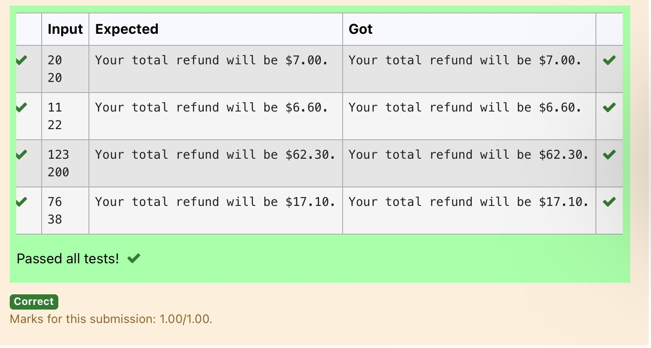

**Ex. No. : 1.6 Date: 06/03/2024**

**Register No.: 231801171 Name: Stergio Eugin**

## [Carpenter](https://www.rajalakshmicolleges.net/moodle/mod/quiz/view.php?id=6379)

Justinisacarpenterwhoworksonanhourlybasis.Heworksinacompanywhere he is paidRs 50for an hour onweekdays and Rs 80 for anhour on weekends.He works10hrsmoreonweekdaysthanweekends.Ifthesalarypaidforhimisgiven, write a program to find the number of hours he has worked on weekdays and weekends.

**Hint:**

Ifthefinalresult(hrs)arein -veconvertthatto+veusingabs()function The abs() function returns the absolute value of the given number.

number=-20

absolute_number=abs(number) print(absolute_number)

# Output:20

**SampleInput:**

450

**SampleOutput:**

weekdays10.38

weekend0.38

**Forexample:**

|  |  |
| --- | --- |
| **Input** | **Result** |
| 450 | weekdays10.38  weekend0.38 |

# Program:

s=int(input()) a=(500-s)/130

print("weekdays{:.2f}".format(abs(a)+10))

print("weekend{:.2f}".format(abs(a)))

Output:

